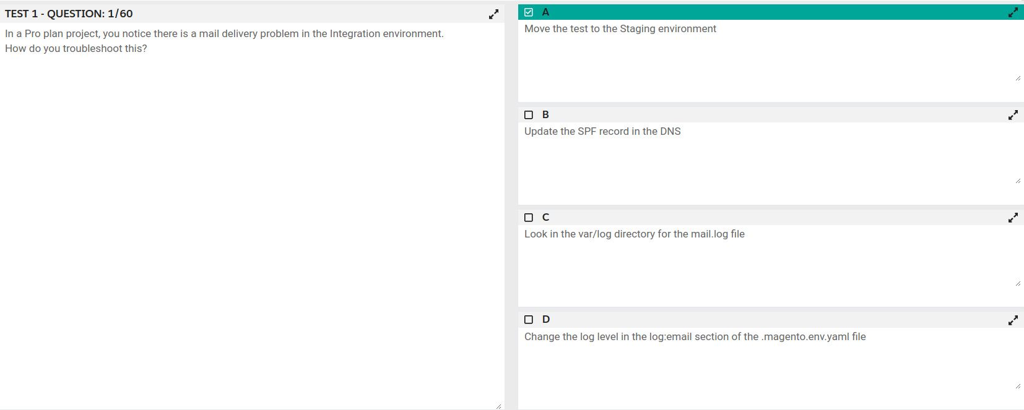

Question #2 Topic 1

You have a Starter project. Your code is ready for testing in the Staging environment, but you need the latest data from Production.  
What do you do to update the Staging environment?

* A. Log in to the Project Web UI, choose the Staging environment, and click Sync
* **B. Log in to the Project Web UI, choose the Staging environment, and click Merge**
* C. Checkout the Staging branch and use the git push origin -f command
* D. Checkout the Production environment and use the magento-cloud sync CLI command

Question #3 Topic 1

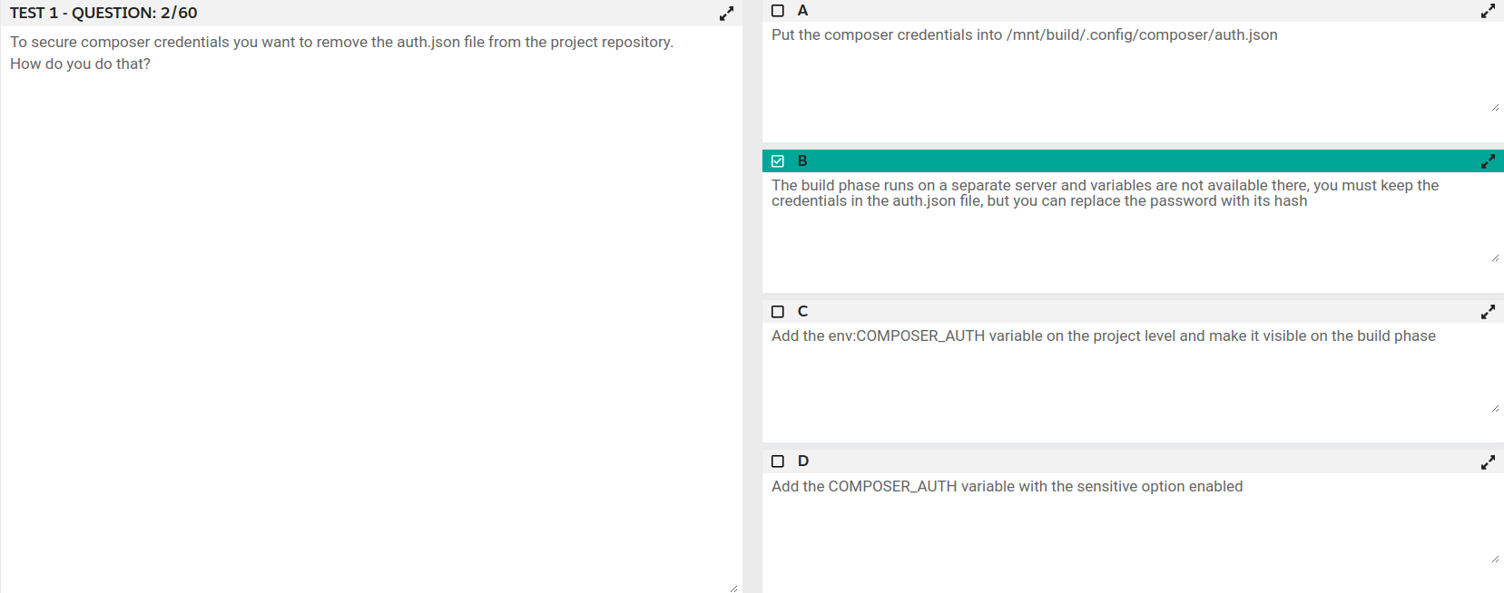

Question #4 Topic 1

While investigating an inherited Magento Commerce Cloud project, you notice the following SCD_MATRIX configuration in .magento.env.yaml: stage: global:  
SCD_MATRIX:  
"magento/backend":  
language:  
- en_US  
What is the effect of this configuration?

* A. Static content for frontend themes is generated during the deploy phase
* B. All frontend theme static content will be reused from the previous deployment

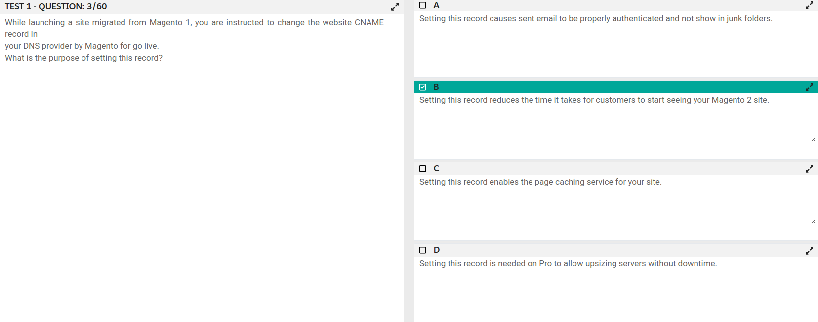

Question #6 Topic 1

While launching a site migrated from Magento 1, you are instructed to change the website CNAME record in your DNS provider by Magento for go live.  
What is the purpose of setting this record?

* A. Setting this record causes sent email to be properly authenticated and not show in junk folders.
* B. Setting this record enables the page caching service for your site.
* C. Setting this record is needed on Pro to allow upsizing servers without downtime.
* **D. Setting this record reduces the time it takes for customers to start seeing your Magento 2 site.**

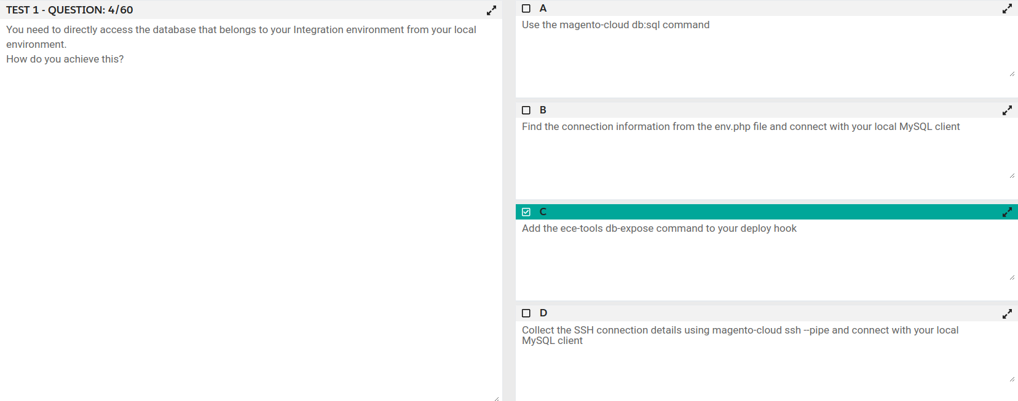

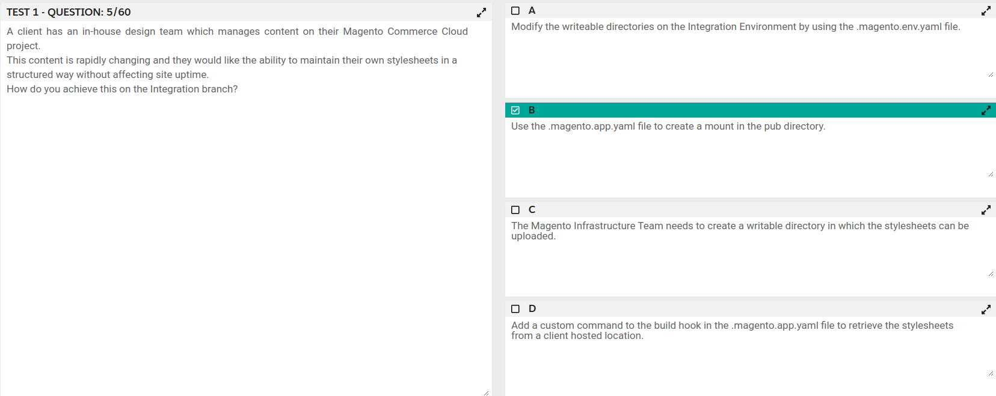

Question #9 Topic 1

A client has an in-house design team which manages content on their Magento Commerce Cloud project. This content is rapidly changing and they would like the ability to maintain their own stylesheets in a structured way without affecting site uptime.  
How do you achieve this on the Integration branch?

* A. Modify the writeable directories on the Integration Environment by using the .magento.env.yaml file.
* B. Add a custom command to the build hook in the .magento.app.yaml file to retrieve the stylesheets from a client hosted location.
* C. The Magento Infrastructure Team needs to create a writable directory in which the

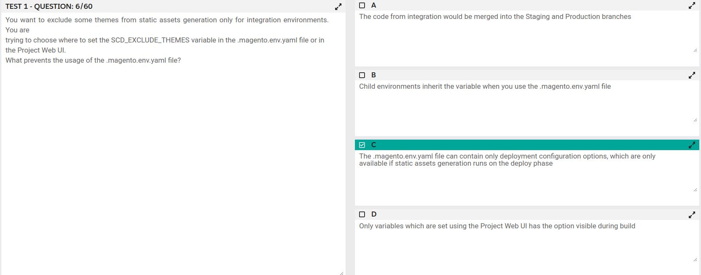

Question #11 Topic 1

You are migrating an existing Magento 2 website to Magento Commerce Cloud. After setting up the project you would like to migrate the database to the  
Integration branch. The database import fails with a disk space error.  
How do you migrate the database without data loss?

* A. Configure the mysql disk size using a variable in the .magento.env.yaml file
* B. Open a Magento Support ticket to increase the Integration branch disk size
* C. Trim down the database to a smaller size
* **D. Configure the mysql disk size in the .magento/services.yaml file**

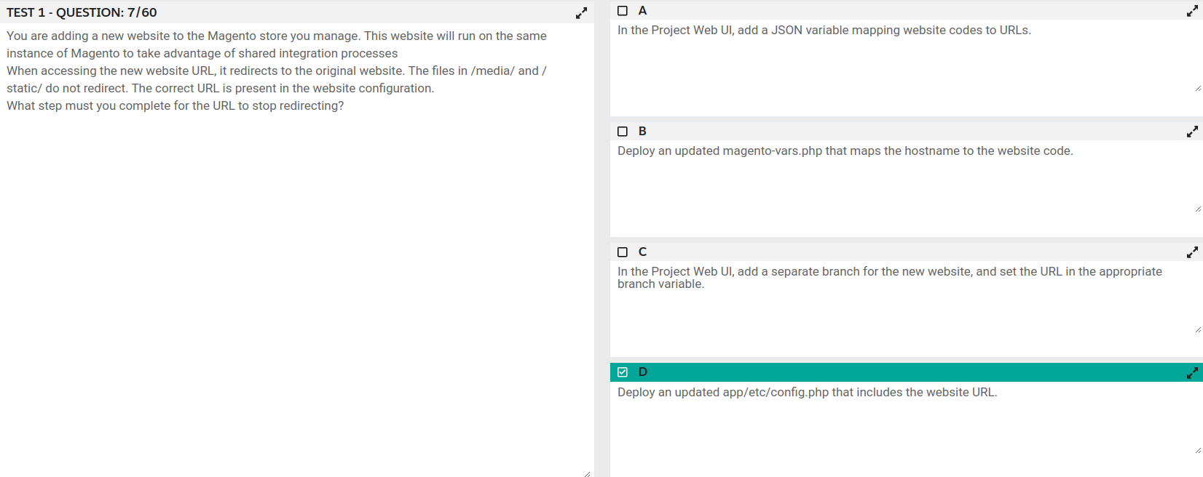

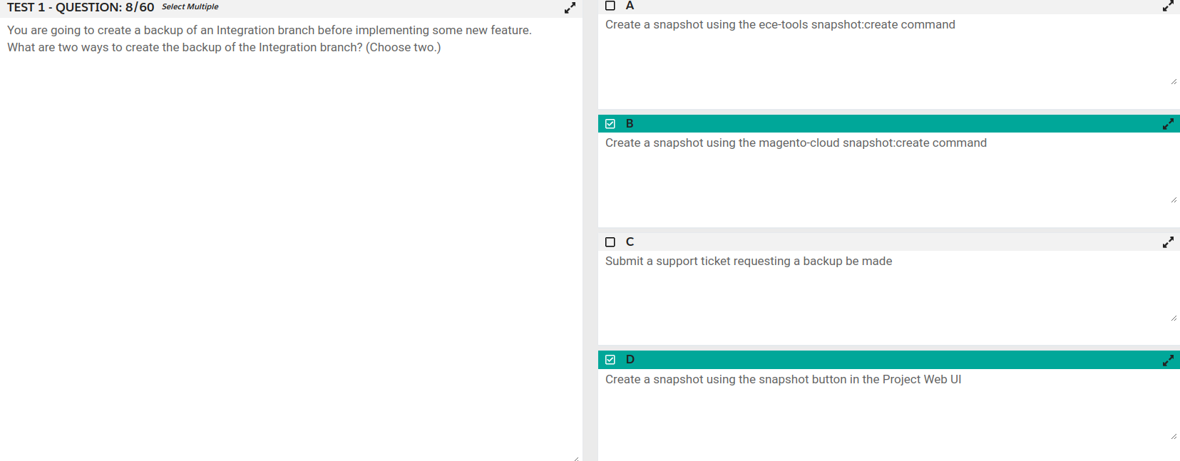

Question #14 Topic 1

You are a technical admin on a Magento Commerce Cloud account. A coworker needs to submit a support request with Magento Support.  
What is needed to enable support ticket access?

* **A. Ask the account owner to add the user to shared access.**
* B. Ask the launch manager to create a support account for this user.
* C. Change the environment access role to contributor for this user.
* D. Update the project role of this user to administrator.

Question #15 Topic 1

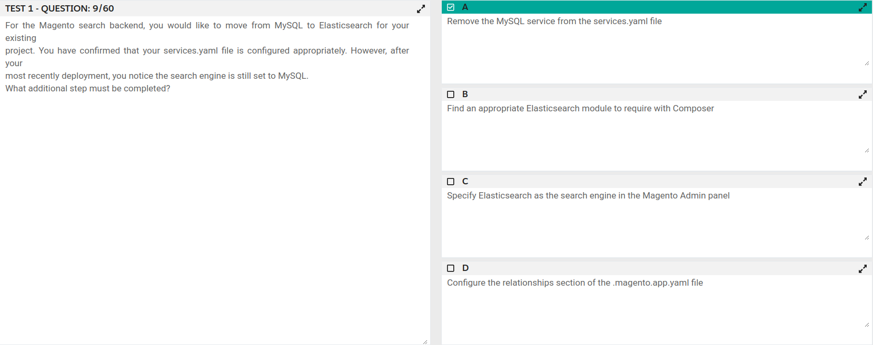

Question #16 Topic 1

On a project that deploys static content during the build phase, a merchant states the deploy phase is still taking too long. You consider turning off JavaScript minification to reduce the build time.  
Besides reducing the build phase time, what two consequences does turning off JavaScript minification have? (Choose two.)

* **A. The deploy artifact size will be decreased because of the larger JavaScript can be symlinked**
* B. Browsing the store will be slower because larger JavaScript files have to be downloaded
* C. The deploy phase will be shorter because JavaScript can be symlinked from init instead of copied

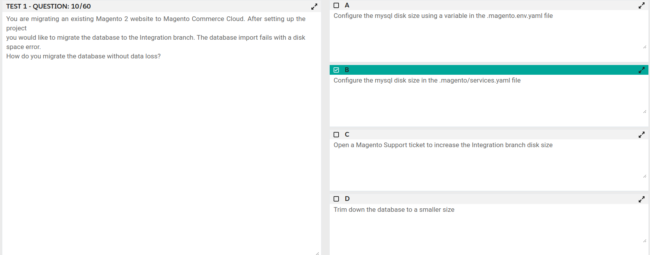

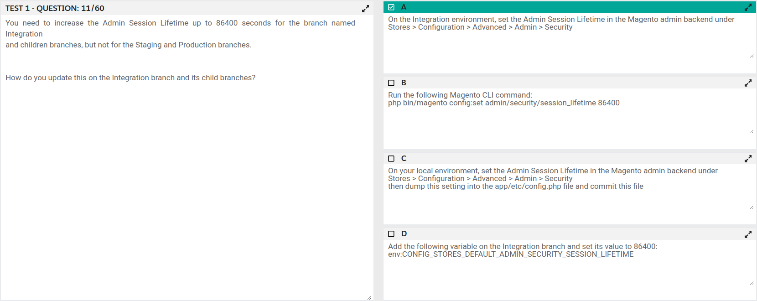

Question #19 Topic 1

Magento Support advises you to upgrade to the latest release of ece-tools matching the project's Magento Commerce version 2.3.1.  
How do you do that?

* A. Require the exact version with composer require magento/ece-tools:2.3.1-pX where X is the latest release number
* B. Clone the repository github.com/magento/ece-tools and copy the src/ folder to vendor/magento/ece-tools/src
* **C. Run the command composer update magento/ece-tools**
* D. Run the command ece-tools self-upgrade

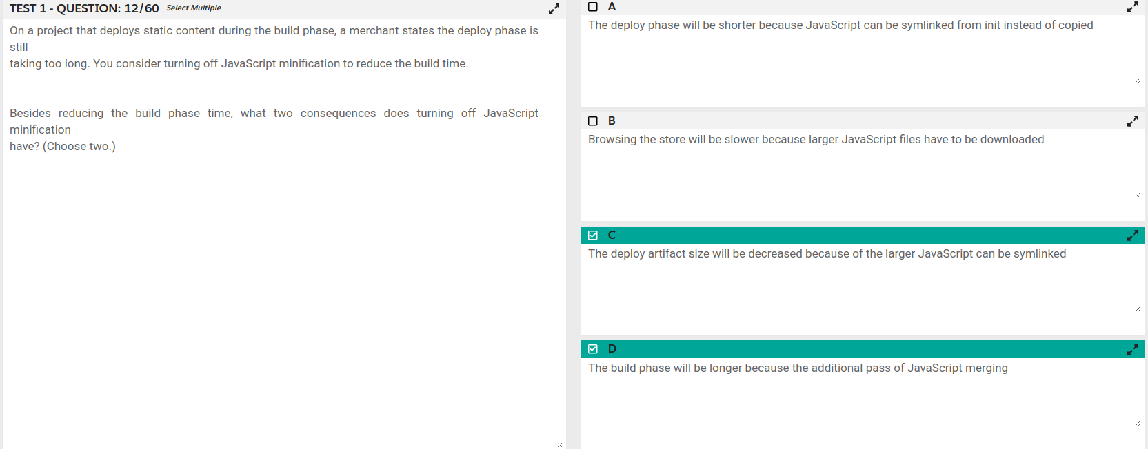

Question #21 Topic 1

You are going to create a backup of an Integration branch before implementing some new feature.  
What are two ways to create the backup of the Integration branch? (Choose two.)

* A. Create a snapshot using the ece-tools snapshot:create command
* **B. Create a snapshot using the snapshot button in the Project Web UI**
* **C. Create a snapshot using the magento-cloud snapshot:create command**
* D. Submit a support ticket requesting a backup be made

Question #22 Topic 1

A merchant using Magento Commerce Cloud Pro reports an issue with an order missing transaction

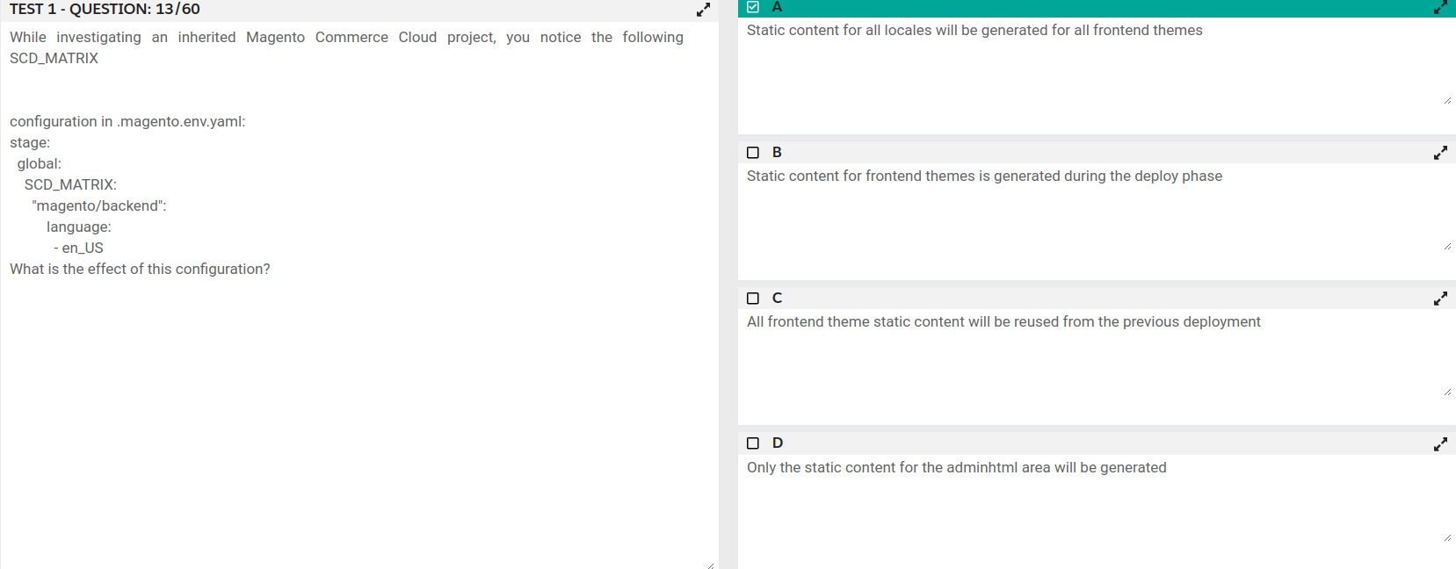

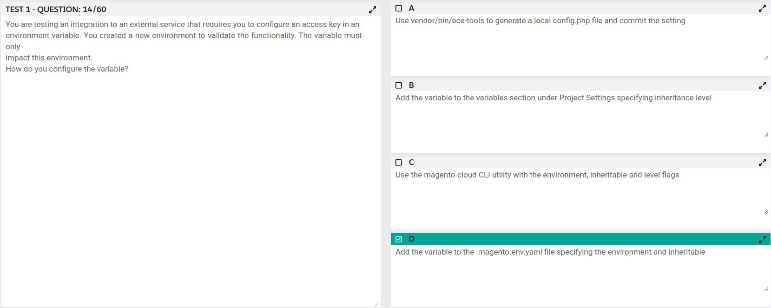

Question #25 Topic 1

You are reviewing a third party extension for Magento Commerce Cloud compatibility.  
Which pattern makes a module incompatible with Magento Commerce Cloud?

* A. Direct instantiation by the ObjectManager of non-generated classes in .phtml template files
* **B. Direct instantiation by the ObjectManager in non-constructor methods with the class also being referenced in the constructor signature**
* C. Configuration referencing generated Proxy classes in the modules etc/frontend/di.xml file
* D. Direct instantiation of generated classes by the ObjectManager without the class being referenced in the constructor

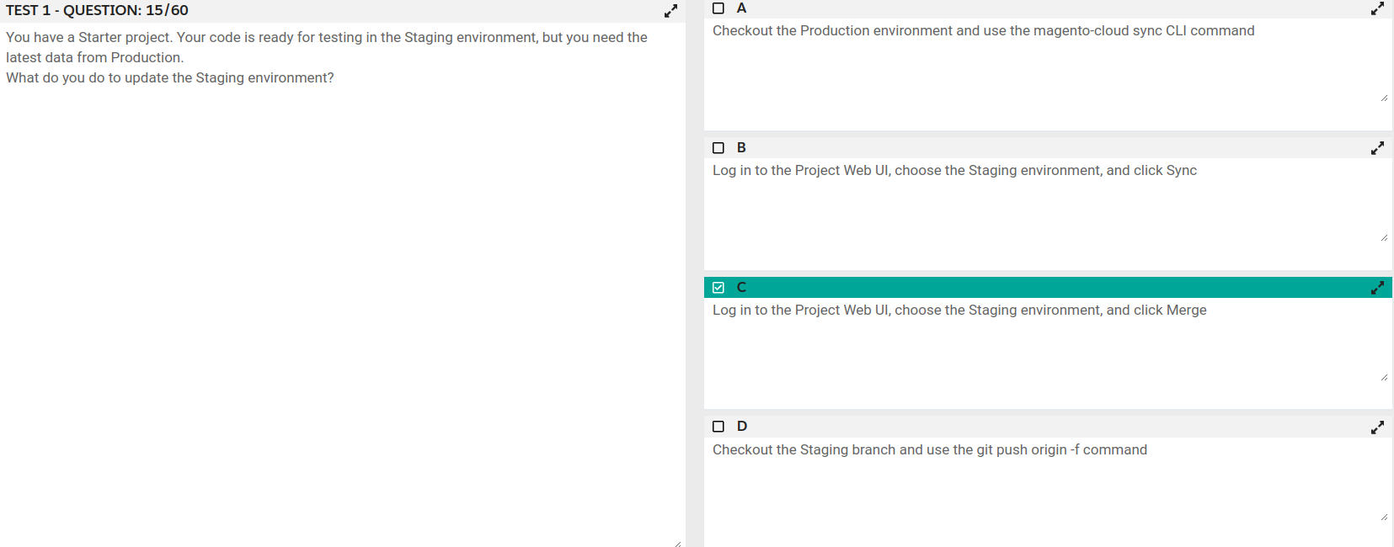

Question #27 Topic 1

In a Pro plan project, you notice there is a mail delivery problem in the Integration environment.  
How do you troubleshoot this?

* A. Change the log level in the log:email section of the .magento.env.yaml file
* B. Update the SPF record in the DNS
* C. Look in the var/log directory for the mail.log file
* **D. Move the test to the Staging environment**

Question #28 Topic 1

You are reviewing a third party extension for Magento Commerce Cloud compatibility. You

